# 

# Key Dates:

**Friday 18 September 2015**

End of term 3

**Tuesday 6 October**

Term 4 commences for students

**Monday 12 & 13 October**

Primary 2 camp to Taronga Zoo

**Friday 23 October**

Grandparents Day Celebration

.

St George School Newsletter

Ana-Lucia Mowle R/ Principal 4 September 2015

# Message from the R/Principal

Dear Parents/Carers,

The past fortnight students have celebrated and engaged in various activities associated with Science Week, Book Week as well as Literacy & Numeracy Week. It was wonderful to see the students motivation and engagement

# Science Week

Science week was celebrated in week 6 of this term. Students participated in many activities related to science topics. The theme for Science week was **‘the making waves: the science of light** ‘. Each day student’s accessed the sensory room where they engaged in lessons associated with light. These activities included ‘Bubbles & fluorescent light’, ‘Aim the torch’, ‘Music & light’, ‘an investigation using ice cubes’ and a ‘glow in the dark story – the solar system’.

# Book Week

In week 7, students shared ‘books that light up their world’ during library class.

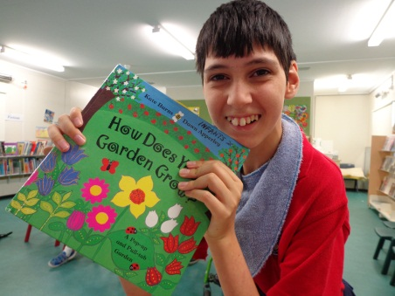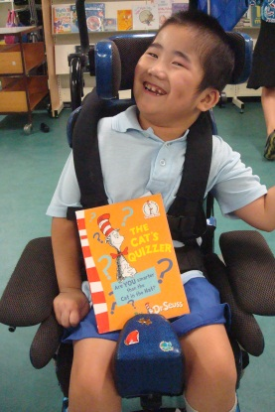

**Many happy returns to our**

**September Birthdays**



Yamma Rammo will turn 9 on

27 September

Jim Chen will turn 17 on 14 September

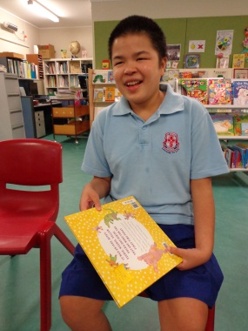

# Congratulations to our award recipients at our most recent assembly

# C:\Users\dmurphy9\AppData\Local\Microsoft\Windows\Temporary Internet Files\Content.IE5\XKL0TTR6\gold-red-star-clip-art-thumb3312717[1].jpg

St George School aims to provide a stimulating learning environment that has

high expectations for all students, focuses on the abilities of students and

promotes and celebrates student successes (School Plan Strategic Direction 1).

Congratulations to our recipients at our last assembly (in week 8):

**Primary:**  Ittai Shveibish, Hailee Scifleet, Mouemin Hammoud, Yamma Rammo

**Middle:**  Matthew Chiotis, Ruby Balkwell,

**Secondary:**  Julia Wainwright, Kara Crawley, Monique Redmond, Jim Chen

**Environment Award:** Secondary 3 Class

## P&C Notice

# **Next P&C Meeting**

# **Thursday**

# **29 October 2015**

# **in the staffroom at 11.30am**

This will be our last P&C meeting for the year.

## All welcome

***********************

# P&C Fundraiser

**InnQUIZitive Trivia**

**Thursday night**

**3 September 2015**

**at Beverly Park Golf Club**

**7.00pm – 9.30pm**

## C:\Users\amowle\Desktop\schools spec.PNG

## Schools Spectacular

We are very excited to be participating in the Schools Spectacular this year. These students Ashleigh Kelly, Mohammed Jomaa, Joshua Sale, Angel-Rose Papapavlos, Liam McManus and Kate Beardsley auditioned and were successful recipients to participate in the 2015 Schools Spectacular. I would like to congratulate these students and look forward to seeing them perform with other students from all over the state.

Tickets for this event go on sale to the public on ***Tuesday 1 September***. If you would like to buy tickets for this event you need to order them through ticketek. For details about pricing, visit http://premier.ticketek.com.au/shows/show.aspx?sh=SCHOOLSS15 this is an event not to be missed.

## Steptember – Fundraising for Cerebral Palsy

Monique Redmond’s cousin Nisha has registered a team to raise money for cerebral palsy research. Nisha has written about Monique being her inspiration. If anyone would like to donate to this worthy cause you need to log into the site Steptember.org.au go to teams and put log into “Nisha Bryant & Team” .Thank you for your support.

# Deadly

activities

# 

# Science Week

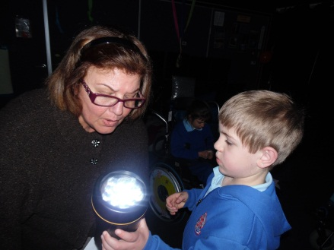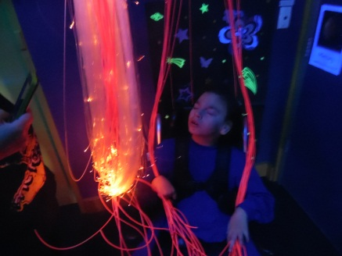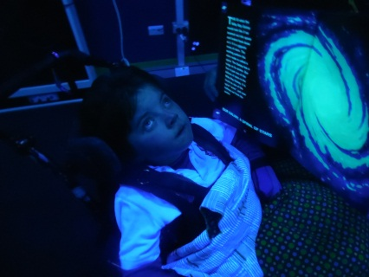

# Literacy & Numeracy Week

This week we celebrated Literacy & Numeracy Week. Each class shared an activity each afternoon, from sensory stories to numeracy games such as ‘snakes & ladders’. Students enjoyed listening and engaging in these activities.

