Message from the R/Principal
Many happy returns to our
August Birthdays
Dominic Cheuk turned 10 on
30 August

Monique Redmond turned 17 on 15 August

Nasya Hazali turned 18 on 30 August

Jessie Neal turned 13 on 1 August

Eva Giatsios turned 5 on 11 August

Key Dates:
Book Week
commencing 24 August 2015

National Literacy and Numeracy Week commencing 31 August 2015

Coffee & Chat
1 September at 11.20am

Friday 18 September 2015
End of term 3

.
St George School Newsletter
Ana-Lucia Mowle R/ Principal 21 August 2015

Dear Parents/Carers,
It’s hard to believe we are already mid-term. It’s been a very busy couple of weeks here at school with students participating in many activities.

Operation Art
Congratulations to those students who submitted art work into the operation art competition. The artworks will be exhibited at The Armory Gallery, Sydney Olympic Park from the 5 September – 25 October 2015. The exhibition is open daily from 10am-4pm and is free entry.
The 4 students, Oliver Mai, Ashleigh Kelly, Yamma Rammo, and Mark Maurizi will be presented with congratulatory certificates for their work at our next assembly.

Welcome Reath from Denmark
Reath Kawang Nyak commenced his practicum studies at St George School this term. Reath is studying Christianity and Culture Education at university in Denmark. Reath is founder and CEO of Sudanmark Community Association in Denmark (SCA) (2012 - 2014): nonprofit organization. Having survived extreme hardship and trauma, Reath now has a passion for helping people in need. He is a moving and inspirational speaker and will tell his story at our Coffee & Chat session in Term 4.

Deadly Beanies
Thank you for supporting our deadly beanies day. It was wonderful to see so many creative beanies. The students enjoyed showing off their beanies to all their school friends. We raised $243 to support brain cancer research.

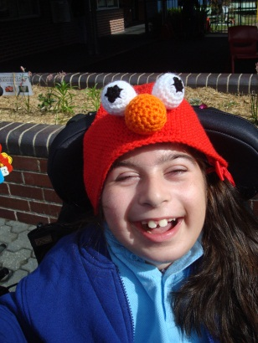
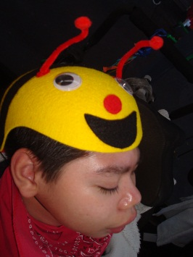
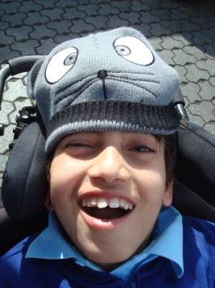

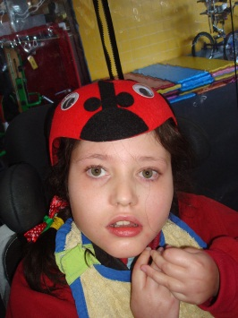
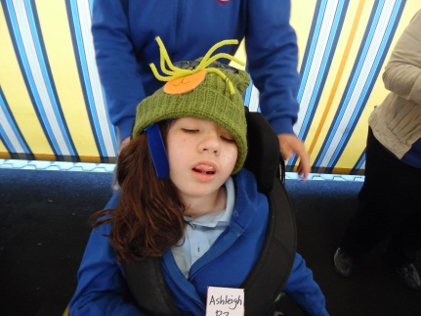

Congratulations to our award recipients at our most recent assembly

St George School aims to provide a stimulating learning environment that has
high expectations for all students, focuses on the abilities of students and
promotes and celebrates student successes (School Plan Strategic Direction 1).

Congratulations to our recipients at our last assembly (in week 6):

Primary: Bella-Rose Thiel, Allegra Watkins, Ismail Flewellen, Oliver Mai,
Middle: Dean Parratt, Aaron Mosel
Secondary: Joshua Sale, Dylan Chaplin, Sebastian Lara-Baris, Jim Chen

Environment Award: Secondary 1 Class

P&C Notice

Next P&C Meeting

Thursday

29 October 2015

in the staffroom at 11.30am

This will be our last P&C meeting for the year.

All welcome
***********************

P&C Fundraiser

InnQUIZitive Trivia
Thursday night

3 September 2015
at Beverly Park Golf Club
7.00pm – 9.30pm

Schools Spectacular
We are very excited to be participating in the Schools Spectacular this year. These students Ashleigh Kelly, Mohammed Jomaa, Joshua Sale, Angel-Rose Papapavlos, Liam McManus and Kate Beardsley auditioned and were successful recipients to participate in the 2015 Schools Spectacular. I would like to congratulate these students and look forward to seeing them perform with other students from all over the state.

Tickets for this event go on sale to the public on Tuesday 1 September. If you would like to buy tickets for this event you need to order them through ticketek. For details about pricing, visit http://premier.ticketek.com.au/shows/show.aspx?sh=SCHOOLSS15 this is an event not to be missed.

Trivia Night
Our trivia fundraiser is in two weeks - $20 per person with all monies raised going to our P&C.
Have you got a group of friends to make or share a table. It will be a fun nigh! We look forward to seeing there.

Please phone the office 9588 2400 to advise the P&C of numbers.

Deadly
activities

NRL Activity Day

Get to know Dan Hunt
Interview
Where were you born? | Darlinghurst Hospital  I grew up in Dapto.
What position do you play? | Five-eight as a junior.  Front row first grade.
Favourite Team to play against? | Parramatta. Played my best game against them scoring 2 tries and taking 36 hit-ups.
Favourite stadium to play at? | Win Jubilee my home ground &  Suncorp one game there were 48 000 spectators. Awesome atmosphere.
Favourite Childhood joke? | Q. How do you make a tissue dance?  A. Put a boogie in it.  Q. What do you call a three legged donkey?  A. Eileen.
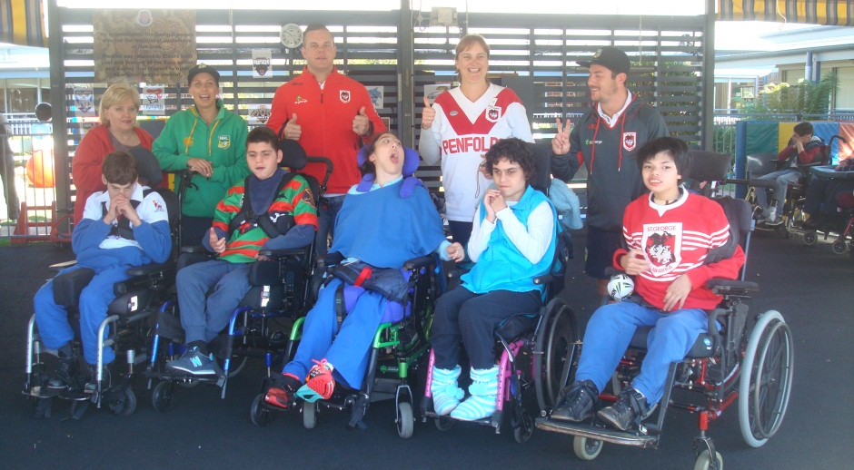
By The Secondary Team

Boccia Competition
On Friday 7 August our students participated in the boccia competition. Well done St George Boccia team. You played 3 games, demonstrating great sportsmanship, supporting your team mates and cheering the other teams. You should be very proud. This year Healthcote High won the day.

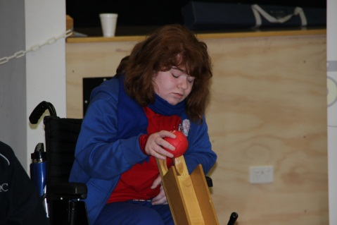
Looking forward to next year!!!

